# System and Software Architecture Description (SSAD)

**NICE e-commerce**

**Team 7**

**Antonis Papantoniou Project Manager/ system integrator**

**Deborah Baker QFP (Team/Web Req)/Assistant PM**

**Dhananjay Nakrani Developer/system integrator**

**Kinglun Au QFP (Web Req)/ Developer**

**Runxuan Wei Developer /system integrator**

**Weijiang Dang QFP (Web Req)/ Developer**

|  |
| --- |
|  |

**2015/12/2**

# Version History

| Date | Author | Version | Changes made | Rationale |
| --- | --- | --- | --- | --- |
| 10/15/15 | WRX | 1.0 | * Created SSAD and added section 1,2,3 | * Initial draft for SSAD |
| 11/27/15 | WRX | 2.0 | * Updated SSAD user case until UC 15, update section 4,5 | * Draft for final SSAD, not final draft |
| 11/30/15 | WRX | 2.1 | * Update all SSAD user cases, table index and plug-in table | * Basically finished |
| 12/2/15 | WRX | 2.2 | * Finished menu update | * Final version |

# Table of Contents

System and Software Architecture Description (SSAD) i

Version History ii

Table of Contents iii

Table of Tables iv

Table of Figures v

1. Introduction 6

1.1 Purpose of the SSAD 6

1.2 Status of the SSAD 6

2. System Analysis 7

2.1 System Analysis Overview 7

2.2 System Analysis Rationale 29

3. Technology-Independent Model 30

3.1 Design Overview 30

3.2 Design Rationale 32

4. Technology-Specific System Design 33

5. Architectural Styles, Patterns and Frameworks 34

# Table of Tables

Table 1: Actors Summary 8

Table 2: Artifacts and Information Summary 9

Table 3-5: Login-Process Description-Action 11

Table 6-8: Logout-Process Description-Action 12

Table 9-11: Buyer registration-Process Description-Action 13

Table 12-15: Vendor registration-Process Description-Action 13

Table 16-17: Add item to cart-Process Description-Action 14

Table 18-20: Check out-Process Description-Action 15

Table 21-23: Edit item in cart-Process Description-Action 16

Table 24-26: Delete item in cart-Process Description-Action 16

Table 27-30: Edit product-Process Description-Action 17

Table 31-34: Create product-Process Description-Action 18

Table 35-37: Delete product-Process Description-Action 19

Table 38-39: Create blog-Process Description-Action 20

Table 40-45: Write comment-Process Description-Action 20

Table 46-48: Search product-Process Description-Action 21

Table 49-50: Vendor email customer-Process Description-Action 22

Table 51-52: Admin email vendor-Process Description-Action 23

Table 53-54: Create and email newsletter-Process Description-Action 23

Table 55-56: Sign up for newsletter-Process Description-Action 24

Table 57-58: Check order-Process Description-Action 24

Table 59-61: Approve new vendor-Process Description-Action 25

Table 62-64: Manage account setting-Process Description-Action 26

Table 65-66: Display vendor-Process Description-Action 26

Table 67-69: Manage vendor-Process Description-Action 27

Table 70-71: Approve pending product-Process Description-Action 28

Table 72: Hardware Component Description 30

Table 73: Web Framework Component Description 31

Table 74: Plug-in Description 32

# Table of Figures

Figure 1: System Context Diagram 7

Figure 2: Artifacts and Information Diagram 9

Figure 3: Process Diagram 11

Figure 4: Hardware Component Class Diagram 30

Figure 5: Web Framework Component Class Diagram 30

### Introduction

#### Purpose of the SSAD

The purpose of the SSAD document is to provide the analysis of the operational concept, design the architecture, and design the implementation of the NICE e-commerce.

#### Status of the SSAD

The current version of the SSAD is at the Final phase. Section 4 and 5 are finished and user cases are updated compare to last version. All the components and architecture of the system to be delivered are documented.

### System Analysis

#### System Analysis Overview

Nice E-commerce website is a project initiated by Eternal Wellness (the client). The final version of the project will provide an online multivendor ecommerce platform where vendors can post their products for sale and customers can buy them. Additionally, each vendor will be able to manage his own blog within the website where he can post information and market his products. PayPal covers the payment processes and Wordpress is used as the main foundation of the platform.

System Context

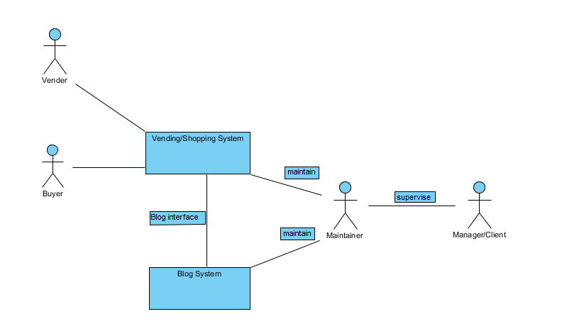

Figure 1: System Context Diagram

Table 1: Actors Summary

|  |  |  |
| --- | --- | --- |
| **Actor** | **Description** | **Responsibilities** |
| Vendor | Users that sell their products through the website | Set correct description about their products, update inventory.  Post appropriate blog posts to market their products. |
| Buyer | Users that buy products through the website | Fill in correct information. |
| Maintainer | Administrators and maintainers for the website | Detect bugs and resolve reported bugs in website.  Maintain database when needed.  Help users with technical difficulties.  Update plugins  Manage home page data |
| Manager/Client | Website owner | Make sure the vendors are selling legal drugs.  Review the website’s operation result, like profit margin. |
| Blog System | The system for users to post and edit health kownledge. | Provide platform for communicate health knowledge |

##### Artifacts & Information

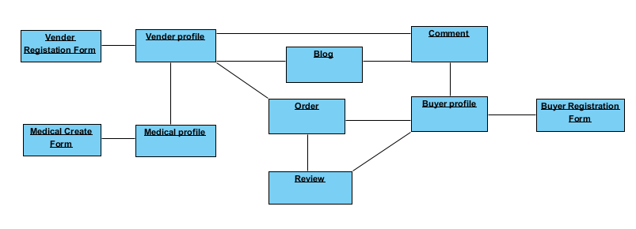Figure 2: Artifacts and Information Diagram

Table 2: Artifacts and Information Summary

|  |  |
| --- | --- |
| **Artifact** | **Purpose** |
| Vendor Registration Form | Contains information about vendor, created when the vendor registers, can be edited later |
| Vendor profile | Contains all information about vendor, including the products sold and blog link. |
| Product Creation Form | Contains new product submission required fields, search tags and media. |
| Product Profile | Visible by all users the profile of the product after admin approval. Contains user reviews |
| Comment | The comments for the blog, can be created by buyer or vendor. |
| Blog | Contains informational posts regarding products/marketing, the poster’s information and the comments made by users. |
| Order | Contains the information about a purchase for one kind of item, including purchase time, purchase count and all delivery information. |
| Buyer profile | Contains all information for buyer, including buying history, comments in blogs and reviews for item. (generated) |
| Review | Reviews left for vendors for the item purchased. |
| Buyer Registration Form | Contains basic information for buyers, created when the buyer registered. |

*(generated): generated information can be found in the diagram

##### Behavior

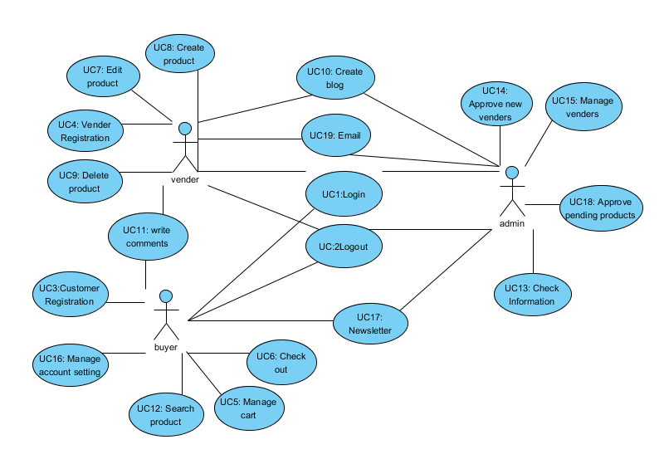

Figure 3: Process Diagram

###### Authentication

Login

Table 3: Process Description-login

|  |  |
| --- | --- |
| **Identifier** | UC1 Login |
| **Purpose** | Determine if a person logging in to the system can be authenticated, and, if so, what the person’s privileges are as a user of the system, i.e., what the person is authorized to do when using the system |
| **Requirements** | Authorization and Authentication |
| **Development Risks** | None |
| **Pre-conditions** | System database is properly initialized.  User is on a computer locally connected to the NICE network. (Logging in from remote computers is not allowed.) |
| **Post-conditions** | If user is authorized s/he is given access to system operations appropriate to his/her role; otherwise, s/he is denied access to the system. |

Table 4: Typical Course of Action-login: successful

|  |  |  |
| --- | --- | --- |
| **Seq#** | **Actor’s Action** | **System’s Response** |
| **1** | User enter username and password and click enter |  |
| **2** |  | Check whether username and password is true. |
| **3** |  | Redirect user to user’s main page |

Table 5: Alternate Course of Action-login: fail

|  |  |  |
| --- | --- | --- |
| **Seq#** | **Actor’s Action** | **System’s Response** |
| **1-2** | same | |
| **3** |  | Displays An error message: “username or password is wrong” in a dialog box |

logout

Table 6: Process Description-logout

|  |  |
| --- | --- |
| **Identifier** | UC2 Logout |
| **Purpose** | To log out of the system |
| **Requirements** | Authorization and Authentication |
| **Risks** | N/A |
| **Pre-conditions** | The user is a NICE User  The user’s login session still exists |
| **Post-conditions** | The user login session is terminated.  The user is detached from the system |

Table 7: Typical Course of Action-logout

|  |  |  |
| --- | --- | --- |
| **Seq#** | **Actor’s Action** | **System’s Response** |
| **1** | User clicks the “log out” hypertext |  |
| **2** |  | End the session with this user and Display a message: “you have logged out of the system” in a dialog box |

Table 8: Exceptional Course of Action-logout

|  |  |  |
| --- | --- | --- |
| **Seq#** | **Actor’s Action** | **System’s Response** |
| **1** | User tries to directly load logout page |  |
| **2** |  | An error message: “you have not logged in yet”. |

###### Registration

Buyer registration

Table 9: Process Description-submit buyer registration

|  |  |
| --- | --- |
| **Identifier** | UC- 3 Submit Application |
| **Purpose** | User register through online system, no need to register in person. |
| **Requirements** | Online application |
| **Development Risks** | None |
| **Pre-conditions** | System database is properly initialized  User has loaded application page |
| **Post-conditions** | User become a registered user. |

Table 10: Typical Course of Action-success registration

|  |  |  |
| --- | --- | --- |
| **Seq#** | **Actor’s Action** | **System’s Response** |
| **1** | Fill in all required data, click submit |  |
| **2** |  | Add new user record into database |
| **3** |  | Redirect user to main page |

Table 11: Alternate Course of Action—fail registration

|  |  |  |
| --- | --- | --- |
| **Seq#** | **Actor’s Action** | **System’s Response** |
| **1** | Fill in some data, click submit |  |
| **2** |  | Dialog in webpage “you haven’t filled all information correctly” |

Vendor registration

Table 12: Process Description-submit vendor registration

|  |  |
| --- | --- |
| **Identifier** | UC- 4 Vendor Registration |
| **Purpose** | Vendors register through online system, no need to register in person. |
| **Requirements** | Online application |
| **Development Risks** | None |
| **Pre-conditions** | System database is properly initialized  Vendor has loaded application page |
| **Post-conditions** | Vendor becomes registered. |

Table 13: Typical Course of Action-success registration

|  |  |  |
| --- | --- | --- |
| **Seq#** | **Actor’s Action** | **System’s Response** |
| **1** | Fill in all required data, click submit |  |
| **2** |  | Add new user record into database |
| **3** |  | Redirect user to main page |

Table 14: Alternate Course of Action—fail registration

|  |  |  |
| --- | --- | --- |
| **Seq#** | **Actor’s Action** | **System’s Response** |
| **1** | Fill in some data, click submit |  |
| **2** |  | Dialog in webpage “you haven’t filled all information correctly or you are not in qualified vendor list” |

Table 15: Alternate Course of Action—fail registration

|  |  |  |
| --- | --- | --- |
| **Seq#** | **Actor’s Action** | **System’s Response** |
| **1** | Fill in all data, not in vendor list, click submit |  |
| **2** |  | Dialog in webpage “you haven’t filled all information correctly or you are not in qualified vendor list” |

###### Buy product

Add item to cart

Table 16: Process Description-add item to cart

|  |  |
| --- | --- |
| **Identifier** | UC5 Manage cart |
| **Purpose** | Easier for buyer to shop, do not need to pay for each item individually |
| **Requirements** |  |
| **Development Risks** |  |
| **Pre-conditions** | User logged in. |
| **Post-conditions** | None |

Table 17: Typical Course of Action

|  |  |  |
| --- | --- | --- |
| **Seq#** | **Actor’s Action** | **System’s Response** |
| **1** | Click “add to cart” button of the product |  |
| **2** |  | Add the product in customer’s pending buying list |

Check out

Table 18: Process Description-check out

|  |  |
| --- | --- |
| **Identifier** | UC6 check out |
| **Purpose** | Ensure safety and convenient check out for users. |
| **Requirements** |  |
| **Development Risks** |  |
| **Pre-conditions** | Has at least 1 item in cart |
| **Post-conditions** | Cart has 0 items and each item purchased will generate an order for buyer and vendor history |

Table 19: Typical Course of Action

|  |  |  |
| --- | --- | --- |
| **Seq#** | **Actor’s Action** | **System’s Response** |
| **1** | Buyer select payment method |  |
| **2** |  | Redirect to third party payment page with total amount |
| **3** | Finish payment |  |
| **4** |  | Get receipt from third party payment method, clear cart item and generate orders |

Table 20: Alternate Course of Action

|  |  |  |
| --- | --- | --- |
| **Seq#** | **Actor’s Action** | **System’s Response** |
| **1-2** | Same | |
| **3** | Buyer did not finish payment |  |
| **4** |  | Remain cart item |

Edit item in cart

Table 21: Process Description-check out

|  |  |
| --- | --- |
| **Identifier** | UC5 Manage cart |
| **Purpose** | Edit the quantity of item in cart |
| **Requirements** |  |
| **Development Risks** |  |
| **Pre-conditions** | Has at least 1 item in cart, in cart page |
| **Post-conditions** | The quantity of item is changed correctly |

Table 22: Typical Course of Action

|  |  |  |
| --- | --- | --- |
| **Seq#** | **Actor’s Action** | **System’s Response** |
| **1** | Enter new quantity in the item’s quantity field or click up/down button to change the quantity; then click update cart |  |
| **2** |  | Redirect to cart page and notify user cart updated. |

Table 23: Failure of Action

|  |  |  |
| --- | --- | --- |
| **Seq#** | **Actor’s Action** | **System’s Response** |
| **1** | Same | |
| **2** |  | Redirect to cart page and notify user cart quantity cannot be updated. |

Delete item in cart

Table 24: Process Description-check out

|  |  |
| --- | --- |
| **Identifier** | UC5 Manage cart |
| **Purpose** | Delete unwanted items in cart. |
| **Requirements** |  |
| **Development Risks** |  |
| **Pre-conditions** | Has at least 1 item in cart, in cart page |
| **Post-conditions** | The deleted item will be removed from cart. |

Table 25: Typical Course of Action

|  |  |  |
| --- | --- | --- |
| **Seq#** | **Actor’s Action** | **System’s Response** |
| **1** | Change the quantity of the item to 0 then click update. |  |
| **2** |  | Redirect to cart page and notify user cart updated. |

Table 26: Failure of Action

|  |  |  |
| --- | --- | --- |
| **Seq#** | **Actor’s Action** | **System’s Response** |
| **1** | Same | |
| **2** |  | Redirect to cart page and notify user cart quantity cannot be updated. |

###### Vendor Manage product

Edit product

Table 27: Process Description

|  |  |
| --- | --- |
| **Identifier** | UC7 edit product |
| **Purpose** | Edit product information |
| **Requirements** |  |
| **Development Risks** |  |
| **Pre-conditions** | Product exists, vendor in product page, vendor logged in |
| **Post-conditions** | Product information edited. |

Table 28: Typical Course of Action

|  |  |  |
| --- | --- | --- |
| **Seq#** | **Actor’s Action** | **System’s Response** |
| **1** | Vendor click edit button for specific product |  |
| **2** |  | Redirect vendor to the product edit page. |
| **3** | Input new information about the product and click update. |  |
| **4** |  | Update the new information in product page and send a dialog “Update success” |

Table 29: Alternate Course of Action

|  |  |  |
| --- | --- | --- |
| **Seq#** | **Actor’s Action** | **System’s Response** |
| **1-2** | Same | same |
| **3** | Click “back” button. |  |
| **4** |  | Redirect vendor to product list page with dialog “change unsaved” |

Table 30: Exceptional Course of Action

|  |  |  |
| --- | --- | --- |
| **Seq#** | **Actor’s Action** | **System’s Response** |
| **1-2** | Same | same |
| **3** | Input invalid information and click update |  |
| **4** |  | Dialog with ”invalid information, please re-enter data” |

Create product

Table 31: Process Description

|  |  |
| --- | --- |
| **Identifier** | UC8 Create product |
| **Purpose** | Create product information |
| **Requirements** |  |
| **Development Risks** |  |
| **Pre-conditions** | vendor logged in |
| **Post-conditions** | New product created |

Table 32: Typical Course of Action

|  |  |  |
| --- | --- | --- |
| **Seq#** | **Actor’s Action** | **System’s Response** |
| **1** | Vendor click Create button |  |
| **2** |  | Redirect vendor to the product Create page. |
| **3** | Input new information about the product and click Create. |  |
| **4** |  | Update the new information in product page and send a dialog “Create success” |

Table 33: Alternate Course of Action

|  |  |  |
| --- | --- | --- |
| **Seq#** | **Actor’s Action** | **System’s Response** |
| **1-2** | Same | Same |
| **3** | Click “back” button. |  |
| **4** |  | Redirect vendor to product list page with dialog “change unsaved” |

Table 34: Exceptional Course of Action

|  |  |  |
| --- | --- | --- |
| **Seq#** | **Actor’s Action** | **System’s Response** |
| **1-2** | Same | Same |
| **3** | Input invalid information and click Create |  |
| **4** |  | Dialog with ”invalid information, please reenter data” |

Delete product

Table 35: Process Description

|  |  |
| --- | --- |
| **Identifier** | UC9 Delete product |
| **Purpose** | Delete product information |
| **Requirements** |  |
| **Development Risks** |  |
| **Pre-conditions** | vendor login |
| **Post-conditions** | Product Deleted. |

Table 36: Typical Course of Action

|  |  |  |
| --- | --- | --- |
| **Seq#** | **Actor’s Action** | **System’s Response** |
| **1** | Vendor click Delete button for specific product |  |
| **2** |  | send a dialog “Are you sure to delete this product?” |
| **3** | click “yes”. |  |
| **4** |  | send a dialog “Delete success”, delete product from database |

Table 37: Alternate Course of Action

|  |  |  |
| --- | --- | --- |
| **Seq#** | **Actor’s Action** | **System’s Response** |
| **1-2** | Same | same |
| **3** | Click “back” button. |  |
| **4** |  | Redirect vendor to product list page with dialog “change unsaved” |

###### Post blog

Create blog

Table 38: Process Description

|  |  |
| --- | --- |
| **Identifier** | UC10 Create blog |
| **Purpose** | Delete product information |
| **Requirements** |  |
| **Development Risks** |  |
| **Pre-conditions** | Vendor or admin login, in blog page |
| **Post-conditions** | Product Deleted from database and the web |

Table 39: Typical Course of Action

|  |  |  |
| --- | --- | --- |
| **Seq#** | **Actor’s Action** | **System’s Response** |
| **1** | Click post blog |  |
| **2** |  | Redirect to write blog page |
| **3** | Write new blog and click post |  |
| **4** |  | New blog is posted on website and added into database |

Write comment

Table 40: Process Description

|  |  |
| --- | --- |
| **Identifier** | UC11 write comments |
| **Purpose** | Give feedback for blogs, can from both vendor and buyer |
| **Requirements** |  |
| **Development Risks** |  |
| **Pre-conditions** | In blog page and already login |
| **Post-conditions** | Comment posted under blog and is added to database |

Table 41: Typical Course of Action

|  |  |  |
| --- | --- | --- |
| **Seq#** | **Actor’s Action** | **System’s Response** |
| **1** | Write comments and click post |  |
| **2** |  | Dialog “post success” and redirect to post page |

Table 42: Alternate Course of Action

|  |  |  |
| --- | --- | --- |
| **Seq#** | **Actor’s Action** | **System’s Response** |
| **1** | Click post page |  |
| **2** |  | Dialog “input must be at least 5 characters” |

Table 43: Process Description

|  |  |
| --- | --- |
| **Identifier** | UC11 write comments |
| **Purpose** | Give feedback for products from buyer |
| **Requirements** |  |
| **Development Risks** |  |
| **Pre-conditions** | Made purchase about one product |
| **Post-conditions** | New comment about the product is added |

Table 44: Typical Course of Action

|  |  |  |
| --- | --- | --- |
| **Seq#** | **Actor’s Action** | **System’s Response** |
| **1** | Write comments and click post |  |
| **2** |  | Dialog “post success” and redirect to post page |

Table 45: Alternate Course of Action

|  |  |  |
| --- | --- | --- |
| **Seq#** | **Actor’s Action** | **System’s Response** |
| **1** | Click post page |  |
| **2** |  | Dialog “input must be at least 5 characters” |

###### Search product

Search product

Table 46: Process Description

|  |  |
| --- | --- |
| **Identifier** | UC12 Search product |
| **Purpose** | Help customers to find what they want |
| **Requirements** |  |
| **Development Risks** |  |
| **Pre-conditions** | Buyer login |
| **Post-conditions** | Product matches search result show up |

Table 47: Typical Course of Action

|  |  |  |
| --- | --- | --- |
| **Seq#** | **Actor’s Action** | **System’s Response** |
| **1** | Enter search name and click “search” in main page |  |
| **2** |  | Redirect to main page with a list of product matches the result |

Table 48: Alternate Course of Action

|  |  |  |
| --- | --- | --- |
| **Seq#** | **Actor’s Action** | **System’s Response** |
| **1** | Enter search name and click “search” in main page |  |
| **2** |  | Dialog “No result can be found” |

###### Email

Vendor email customer

Table 49: Process Description-vendor email customer

|  |  |
| --- | --- |
| **Identifier** | UC19 Email |
| **Purpose** | To notify any abnormal about the product delivery |
| **Requirements** |  |
| **Development Risks** |  |
| **Pre-conditions** | Vendor logged in. |
| **Post-conditions** | User get an email from vendor |

Table 50: Typical Course of Action

|  |  |  |
| --- | --- | --- |
| **Seq#** | **Actor’s Action** | **System’s Response** |
| **1** | Check email information for the customer and send the email manually |  |

Admin email vendor

Table 51: Process Description-admin email vendor

|  |  |
| --- | --- |
| **Identifier** | UC19 Email |
| **Purpose** | For admin to communicate with vendor about any concerned issues. |
| **Requirements** |  |
| **Development Risks** |  |
| **Pre-conditions** | Admin logged in, in admin site |
| **Post-conditions** | The vendor received an email from admin |

Table 52: Typical Course of Action

|  |  |  |
| --- | --- | --- |
| **Seq#** | **Actor’s Action** | **System’s Response** |
| **1** | Check email information for the customer and send the email manually |  |

Create and email newsletter

Table 53: Process Description-Create and email newsletter

|  |  |
| --- | --- |
| **Identifier** | UC17 Newsletter |
| **Purpose** | For admin to create newsletter and send them to customers who subscribed newsletter. |
| **Requirements** |  |
| **Development Risks** |  |
| **Pre-conditions** | Admin logged in, in admin site |
| **Post-conditions** | Emails are sent to all subscribed email address. |

Table 54: Typical Course of Action

|  |  |  |
| --- | --- | --- |
| **Seq#** | **Actor’s Action** | **System’s Response** |
| **1** | Click Newsletter tag |  |
| **2** |  | Redirect admin to newsletter main page |
| **3** | Click +new |  |
| **4** |  | Redirect admin select a new theme of newsletter |
| **5** | Select a theme |  |
| **6** |  | Redirect to detail page of creating a newsletter |
| **7** | Fill all information required and click send through proceed to edit |  |
| **8** |  | Notify the admin the newsletter is sent |

Signup for newsletter

Table 55: Process Description-signup for newsletter

|  |  |
| --- | --- |
| **Identifier** | UC17 Newsletter |
| **Purpose** | For customer to get new information about sales. |
| **Requirements** |  |
| **Development Risks** |  |
| **Pre-conditions** | None |
| **Post-conditions** | Newsletter will be sent to desired email address. |

Table 56: Typical Course of Action

|  |  |  |
| --- | --- | --- |
| **Seq#** | **Actor’s Action** | **System’s Response** |
| **1** | Enter email address and click subscribe in the button of main page |  |
| **2** |  | The email address is added to the newsletter sending list. A confirmation email should be sent to that mailbox. |

###### Administration

Check order

Table 57: Process Description

|  |  |
| --- | --- |
| **Identifier** | UC13 check information |
| **Purpose** | Review whether order has not been fulfilled, may notify the vendor later |
| **Requirements** |  |
| **Development Risks** |  |
| **Pre-conditions** | Admin login |
| **Post-conditions** | Show unshipped orders |

Table 58: Typical Course of Action

|  |  |  |
| --- | --- | --- |
| **Seq#** | **Actor’s Action** | **System’s Response** |
| **1** | Click “unshipped orders” |  |
| **2** |  | Redirect to main page with a list of unshipped orders |

Approve new vendors

Table 59: Process Description

|  |  |
| --- | --- |
| **Identifier** | UC14 approve new vendors |
| **Purpose** | Add new certified vendors in the vendor list |
| **Requirements** |  |
| **Development Risks** |  |
| **Pre-conditions** | Admin login |
| **Post-conditions** | New vendor added to the vendor list |

Table 60: Typical Course of Action

|  |  |  |
| --- | --- | --- |
| **Seq#** | **Actor’s Action** | **System’s Response** |
| **1** | Assign a unique code, vendor’s email address and Click “add vendor” |  |
| **2** |  | Vendor’s email will get the unique code for registration and the vendor will be added in vendor list |

Table 61: Alternate Course of Action

|  |  |  |
| --- | --- | --- |
| **Seq#** | **Actor’s Action** | **System’s Response** |
| **1** | Assign a unique code, vendor’s email address and Click “add vendor” |  |
| **2** |  | Dialog “vendor already exists” |

Manage account setting

Table 62: Process Description

|  |  |
| --- | --- |
| **Identifier** | UC16 manage account setting |
| **Purpose** | Edit account setting |
| **Requirements** |  |
| **Development Risks** |  |
| **Pre-conditions** | User login, in my account page |
| **Post-conditions** | User’s account setting is changed. |

Table 63: Typical Course of Action

|  |  |  |
| --- | --- | --- |
| **Seq#** | **Actor’s Action** | **System’s Response** |
| **1** | Click edit button for changing specific setting |  |
| **2** |  | Redirect user to a page for filling the new information of the specific account information. |
| **3** | Change the information and click save |  |
| **4** |  | Notify user the new setting has been saved. |

Table 64: Exception Course of Action

|  |  |  |
| --- | --- | --- |
| **Seq#** | **Actor’s Action** | **System’s Response** |
| **1** | Click edit button for changing specific setting |  |
| **2** |  | Redirect user to a page for filling the new information of the specific account information. |
| **3** | Change the information and click save |  |
| **4** |  | Notify user some columns are required field and must fit the format. |

Display vendors

Table 65: Process Description

|  |  |
| --- | --- |
| **Identifier** | UC13 Check information |
| **Purpose** | Monitor vendors with their sales |
| **Requirements** |  |
| **Development Risks** |  |
| **Pre-conditions** | Admin login |
| **Post-conditions** | Vendor’s sales are displayed |

Table 66: Typical Course of Action

|  |  |  |
| --- | --- | --- |
| **Seq#** | **Actor’s Action** | **System’s Response** |
| **1** | Click vendor side bar |  |
| **2** |  | Redirect user to a vendor page with all vendor with their sales |

Manage vendor

Table 67: Process Description

|  |  |
| --- | --- |
| **Identifier** | UC15 Manage vendor |
| **Purpose** | Suspend vendor if necessary |
| **Requirements** |  |
| **Development Risks** |  |
| **Pre-conditions** | Admin login, in admin site |
| **Post-conditions** | Target vendor is suspended |

Table 68: Typical Course of Action

|  |  |  |
| --- | --- | --- |
| **Seq#** | **Actor’s Action** | **System’s Response** |
| **1** | Click Users, all users tab |  |
| **2** |  | Redirect user to a user page listed with all users |
| **3** | Move mouse on the vendor’s name |  |
| **4** |  | Edit and remove button appears |
| **5** | Click Edit |  |
| **6** |  | Redirect to a page shows vendor details |
| **7** | Change the role in detail page from vendor and click update user |  |
| **8** |  | Notify the admin that the user is updated |

Table 69: Alter Course of Action

|  |  |  |
| --- | --- | --- |
| **Seq#** | **Actor’s Action** | **System’s Response** |
| **1** | Click Users, all users tab |  |
| **2** |  | Redirect user to a user page listed with all users |
| **3** | Move mouse on the vendor’s name |  |
| **4** |  | Edit and remove button appears |
| **5** | Click remove |  |
| **6** |  | Redirect to a page that ask confirmation |
| **7** | Click confirm remove |  |
| **8** |  | Notify the admin that the vendor is removed |

Approve pending product

Table 70: Process Description

|  |  |
| --- | --- |
| **Identifier** | UC18 Approve pending product |
| **Purpose** | Make sure the new product is not illegal |
| **Requirements** |  |
| **Development Risks** |  |
| **Pre-conditions** | Admin login, in admin site, new products are waiting for being approved |
| **Post-conditions** | Product approved |

Table 71: Typical Course of Action

|  |  |  |
| --- | --- | --- |
| **Seq#** | **Actor’s Action** | **System’s Response** |
| **1** | Click Products, products tab |  |
| **2** |  | Redirect to all product list |
| **3** | Click pending |  |
| **4** |  | Redirect to pending product list |
| **5** | Move mouse on the product and click quick edit |  |
| **6** |  | Shows product details |
| **7** | Change the status from pending review to publish and click update |  |
| **8** |  | Notify the admin that the product is updated |

##### Modes of Operation

NICE e-commerce will operate in only one mode, so nothing further need be said of modes of operation.

#### System Analysis Rationale

Administrator registration:

There is no registration for administrator in use case diagram because the administrator account should be built in the database by the manager. This is to prevent the administrator account to be massively created.

Vendor registration:

There is a certified vendor list (maybe a series activation code) in database added by manager. If the vendor is on the list, he/she can continue register the vendor account.

The payment tool will be PayPal. The debit or credit card information will not be stored in the NICE website database, they will deal with the third party payment tool directly.

### Technology-Independent Model

#### Design Overview

##### System Structure

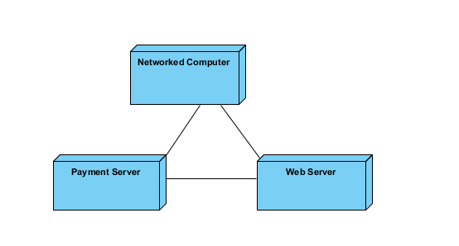

Figure 4: Hardware Component Class Diagram

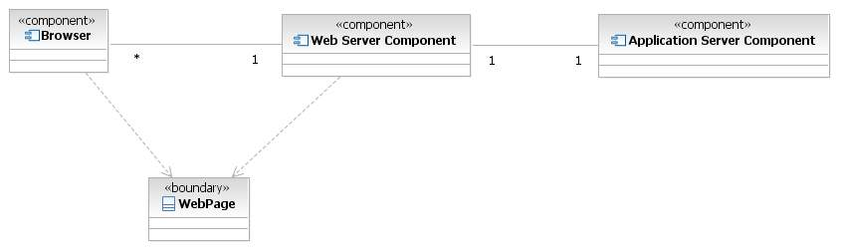

Figure 5: Web Framework Component Classes

Table 72: Hardware Component Description

|  |  |
| --- | --- |
| **Hardware Component** | **Description** |
| Web server | Host website and database |
| Payment server | Process payment |
| Networked computer | User’s computer, process static website view |

The local computer would communicate with web server payment is made. Then the local computer would communicate to payment server. After the transfer is complete, the payment server would send message to web server and redirect the user to web server.

Table 73: Web Framework Component Description

|  |  |
| --- | --- |
| **Web Component** | **Description** |
| Browser | An Internet browser that connects to the NICE web application and is responsible for displaying NICE ecommerce web pages. |
| Web Server Component | The server component that routes all network traffic and requests between external systems and the application server. |
| Application Server Component | The server component where the WordPress hosts NICE website. All the logical computations are done on this component. |
| Web Pages | The actual web pages created by the customized WordPress. |

##### Process Realization

We are an integration team and do not have many things to code in website. All the functions are realized by plug-ins. And some adjustments of code are made with plug-ins to accommodate specific requirements.

Here is a list of plug-ins:

Table 74: Plug-in Description

|  |  |
| --- | --- |
| **Duplicator** | Create a backup of your WordPress files and database. Duplicate and move an entire site from one location to another in a few steps. Create a full snapshot of your site at any point in time. |
| **Jetpack by WordPress.com** | Bring the power of the WordPress.com cloud to your self-hosted WordPress. Jetpack enables you to connect your blog to a WordPress.com account to use the powerful features normally only available to WordPress.com users. |
| **Newsletter** | Newsletter is a cool plugin to create your own subscriber list, to send newsletters, to build your business. |
| **Responsive WordPress Slider - Soliloquy Lite** | Soliloquy is best responsive WordPress slider plugin. This is the lite version. |
| **SiteOrigin CSS** | An advanced CSS editor from SiteOrigin. |
| **WC Vendors** | Allow vendors to sell their own products and receive a commission for each sale. |
| **WooCommerce** | An e-commerce toolkit that helps you sell anything. Beautifully. |
| **WooCommerce Product Archive Customiser** | Allows you to customise WooCommerce product archives. Change the number of product columns and the number of products displayed per page. Toggle the display of core elements and enable some that are not included in WooCommerce core such as stock levels and product categories. |
| **WP User Avatar** | Use any image from your WordPress Media Library as a custom user avatar. Add your own Default Avatar. |
| **YITH WooCommerce Ajax Product Filter** | YITH WooCommerce Ajax Product Filter offers the perfect way to filter all the products of your shop. |
|  |  |

#### Design Rationale

We are an integration team and do not have many things to code in website. All the functions are cooperating with plug-ins. All adjustments of code are made with plug-ins.

Since the integration of plug- Technology-Specific System Design

We are an integration team and do not have many things to code in website. All the functions are cooperating with plug-ins. Our custom code was mostly creating a custom theme or changing directly plugin code to accommodate client needs. This project had a huge scope and it would have taken us many man-hours to complete it potentially vastly exceeding the duration of this course. Using this compromise of Wordpress we were able to deliver all the required functionality within our allocated timeframe.

### Architectural Styles, Patterns and Frameworks

No Frameworks were used.